**Sales Analytics Project Report**

**Objective: -** The purpose of this project is to provide a comprehensive view of business performance of Northwind by analyzing sales, customer behavior, inventory levels, employee productivity, shipping efficiency, and supplier contributions to support data-driven decision making by stakeholders. The expected impact is to revolutionize how Northwind Traders interacts with its data, enabling the company to remain competitive and drive its business forward in the wholesale market landscape.

**Tools used: -** Microsoft Power BI (for dashboards and solving Power BI questions), Power Query (for data cleaning and modeling), DAX (for measures), SQL and Excel (for EDA questions).

**Significance:** -

1. Comprehensive Business View – Provides a 360° perspective of sales, customers, inventory, employees, shippers, and suppliers, enabling integrated decision-making.
2. Data-Driven Insights – Transforms raw transactional data into meaningful KPIs and visual dashboards that support strategic planning.
3. Trend Identification – Helps identify sales patterns, customer behaviour, and market dynamics over time.
4. Performance Evaluation – Assesses employee productivity, shipper efficiency, and supplier contribution, making it easier to spot strengths and weaknesses.
5. Operational Efficiency – Highlights bottlenecks like delayed shipments, low stock, or underperforming suppliers so corrective actions can be taken.
6. Resource Optimization – Supports better allocation of inventory, workforce, and logistics by analyzing demand and performance.
7. Strategic Decision Support – Equips management with actionable insights to boost profitability, streamline operations, and strengthen customer satisfaction.

**Dataset Used**

Table Explanations

Customers Table

This table stores information about the company's customers. It includes fields for customer ID, company name, contact name, contact title, address, city, region, postal code, country, phone, and fax.

Employees Table

This table stores information about the company's employees. It includes fields for employee ID, last name, first name, title, title of courtesy, birth date, hire date, address, city, region, postal code, country, home phone, extension, photo, notes, reports to, and photo path.

Orders Table

This table stores information about the company's orders. It includes fields for order ID, customer ID, employee ID, order date, required date, shipped date, ship via, freight, ship name, ship address, ship city, ship region, ship postal code, and ship country.

Order Details Table

This table stores detailed information about the items within each order. It includes fields for order ID, product ID, unit price, quantity, and discount.

Products Table

This table stores information about the company's products. It includes fields for product ID, product name, supplier ID, category ID, quantity per unit, unit price, units in stock, units on order, reorder level, and whether the product is discontinued.

Suppliers Table

This table stores information about the company's suppliers. It includes fields for supplier ID, company name, contact name, contact title, address, city, region, postal code, country, phone, fax, and home page.

Shippers Table

This table stores information about the company's shipping companies. It includes fields for shipper ID, company name, and phone.

Categories Table

This table stores information about the product categories. It includes fields for category ID, category name, and description.

**Steps: -**

1. EDA – Exploratory Data Analysis

* Data Cleaning: - Checked for null values, duplicates, and corrected data types (dates, numbers).
* Loading: - Loaded the data in to SQL.
* Solution: - Solved the EDA questions using different queries in SQL.
* Formatting: - Then formatted the result by copying it into the Excel.

1. Data Modeling in Power BI

* Designed a schema using different tables.
* Created Measures using DAX:
  + - Total sales
    - Average Order Value
    - Total customers
    - Inventory value
    - Delivery Time etc.

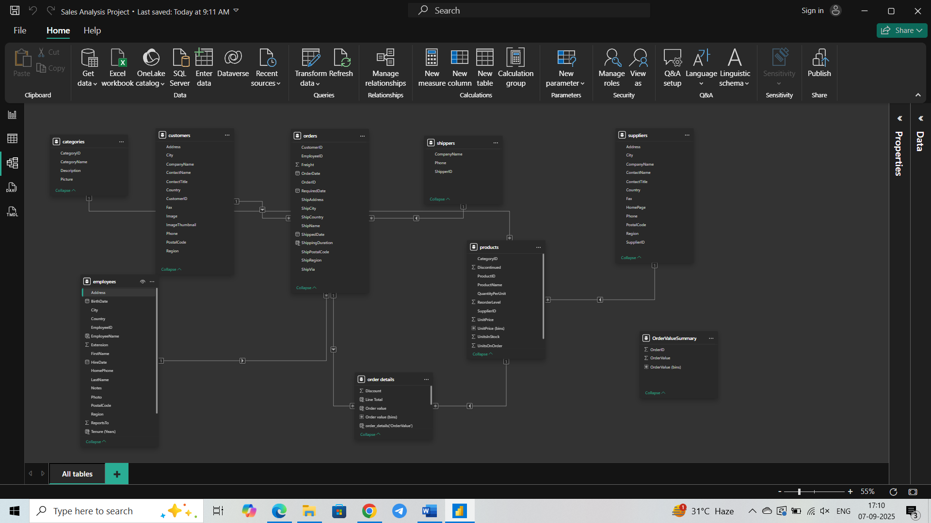**ER Diagram**

1. Power BI questions

* Solved the different questions to create a visualization report.

1. Dashboard Creation

* Using Power BI created a dashboard consisting of different analysis.
  + - Sales Analysis Dashboard
    - Customer Insight Dashboard
    - Inventory Analysis Dashboard
    - Employee Performance Dashboard
    - Shipping Analysis Dashboard
    - Suppliers Insight Dashboard

1. PowerPoint presentation creation
2. Presentation video

**Key Findings**

1. Sales growth trends and top performing categories.
2. Top customers
3. Inventory/stocks conditions (low/out of stock products)
4. Best performing employees
5. Best shipper
6. Supplier concentration and top supplier.

**Conclusion**

This project provides a comprehensive 360° business view of Northwind Traders and enables data-driven decision making for better efficiency and profitability.